1. 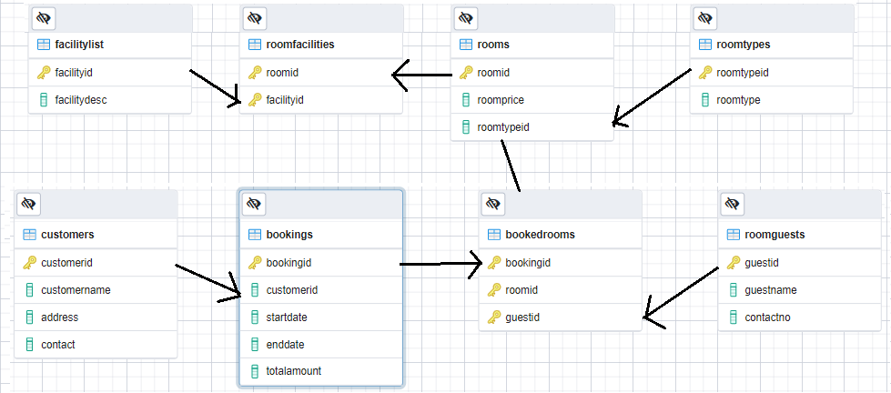Design a database model as below. Load sample data into the database.

**Tech stack / Tools**

1. Java, Spring boot, Spring MVC
2. JSPX, HTML, CSS, Bootstrap
3. SQL, PostgreSQL
4. Junit / Mockito
5. Tomcat 9.x, Eclipse/ STS IDE

Develop a monolithic web application with SpringBoot (Spring MVC) and implement the following functionalities.

* 1. List all the booking details (BookingID, custId, customername, address, contact, startdate, enddate) on a given date.
  2. Get all the facilities provided (Facilityid, FacilityDesc) in a given Room Type.
  3. List the guest details for the given booking id (Guestid, roomid, guestname, contactno).
  4. List the vacant room details on a given date.
  5. Write relevant server side test cases (Junit), (test the service classes using Junit and Mockito)
  6. Generate SonarQube code quality reports.